**Forecasting of  Covid-19 outbreak using Machine Learning and Deep Learning**

Synopsis Submitted to

**DR. PIYUSH YADAV**

Department of Electronics and Communication

Engineering

In Partial Fulfillment of Requirements For Award of the Degree

BACHELOR OF TECHNOLOGY

By:

*AMAN HASAN KHAN ( 1719231014 )*

*HIMANSHU RAWAT ( 1719231047 )*

*JATIN SHARMA ( 1719231048 )*

*ARPIT JAIN ( 1719231024 )*



**G.L. Bajaj Institute of Technology & Management, Greater Noida**

**Dr. A.P.J. Abdul Kalam Technical University, Lucknow**

**(Session: 2020-21)**

* PROBLEM STATEMENT

AS Covid-19 spreads rapidly, timing is an important factor for controlling this disease as early as possible. Hence from the initial stage enormous monitoring is required for the authorities to handle this type of pandemic.

* WHY THIS PROJECT?

Basically, we will be going to predict the confirmed death cases using the past data and to check whether it will be feasible to use machine learning method to evaluate how much prediction results will be close to original data related to Confirmed- Negative-Released-Death cases of Covid-19.

* OBJECTIVE

The objective of this study is to forecast the Covid-19 outbreak using Machine learning and deep learning by December 2020. It will ensure that it’s accuracy must be high and follows the original result, so that it will help the government to take appropriate preventive measures for the betterment of society.

* SOFTWARE REQUIREMENT ANANLYSIS

1. FUNCTIONAL REQUIREMENT

Modules**:-**

* Phase 1**:** Application of Machine Learning
* Phase 2**:** Deep Learning

1. NON- FUNCTIONAL REQUIREMENT

* Software - Python, Jupyter Notebook, Tensorflow, Keras, Matplotlib
* Hardware - Processor: i3

Hard Disk: 16GB

Ram: 4GB

OS: Windows/MacOs /Linux

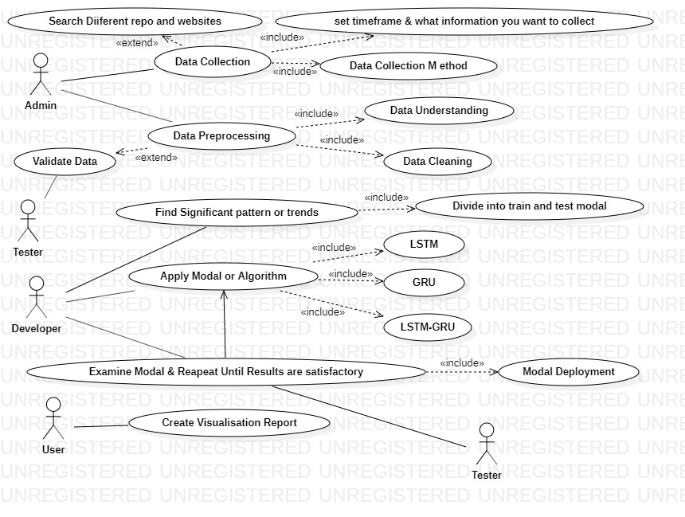

1. SPECIFICATIONS/MAIN FUNCTIONALITIES:
2. In this project, data mining concepts will be exploited for obtaining prediction of confirmed, negative cases, recovered cases, and death cases where Recurrent Neural Network (RNN) is also employed.
3. The real cases and prediction cases will be compared based on some predefined metric.
4. A combined model consisting of Long short-term memory (LSTM) and Gated Recurrent Unit (GRU) will be applied to the dataset finally for training and testing purpose.
5. A comparative study will be drawn amongst the performance of proposed three models-LSTM-RNN, GRU-RNN, and LSTM-GRU-RNN.

* DEPENDENCIES

1. Depends upon the Data set. It must be large.
2. It also depends upon the training data set as well as test data set.
3. It depends on how efficiently we apply the above models.
4. Also depends upon Hyper and Default Parameters.

* REFRENCES:

[1] World Health Organization. WHO Statement Regarding Cluster of Pneumonia Cases in Wuhan, China, 2020.

[2] C. Huang et al., “Clinical features of patients infected with 2019 novel coronavirus in Wuhan, China,” Lancet, vol. 395, no. 10223, pp. 497–506, 2020, doi: 10.1016/S0140-6736(20)30183-5.

[3] C. Anastassopoulou, L. Russo, A. Tsakris, and C. Siettos, “Data-Based Analysis, Modelling and Forecasting of the novel Coronavirus (2019-nCoV) outbreak,” medRxiv, no. February, p. 2020.02.11.20022186, 2020, doi: 10.1101/2020.02.11.20022186.

[4] Z. Hu, Q. Ge, S. Li, L. Jin, and M. Xiong, “Artificial Intelligence Forecasting of Covid-19 in China,” pp. 1–20, 2020.

[5] S. J. Fong, G. Li, N. Dey, R. Gonzalez-Crespo, and E. Herrera-Viedma, “Finding an Accurate Early Forecasting Model from Small Dataset: A Case of 2019-nCoV Novel Coronavirus Outbreak,” Int. J. Interact. Multimed. Artif. Intell., vol. InPress, no. InPress, p. 1, 2020, doi: 10.9781/ijimai.2020.02.002.